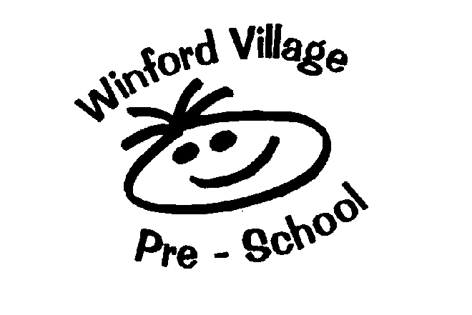
Registered Charity Number - 1072298

Social Media Networking Policy

The purpose of this policy is to:
- Ensure safeguarding procedures are adhered to.
- Ensure that staff are aware of their responsibilities in connection with the use of social networking sites and of the risks associated with the inappropriate use of social networking sites and any impacts in relation to their employment
- Safeguard staff at the setting in connection with the use of social networking children sites and minimise the risk that they make themselves vulnerable to allegations
- Ensure the setting maintains its duty to safeguard children, the reputation of the setting and those who work for it.

This policy is to cover all individuals within the setting in a paid or voluntary capacity including parent helpers, committee members, those on work experience/college placements and agency staff. Third parties working in partnership with the setting are also expected to adhere to this guidance.

This policy applies to social networking sites, personal web pages, and internet presence which make available personal information (including images) and opinions to the general public including but not limited to Facebook, Pinterest, Snapchat, WhatsApp, Instagram, MSN, Twitter, YouTube, Blogs, Wikis, Forums, Bulletin boards, Chatrooms, Mulit-player online gaming, Viral worlds and instant messenger.

This policy will be part of the induction process for all new staff at the setting and will be regularly shared with all existing members of staff.
The setting does not discourage colleagues at the setting from using social networking sites, however, all staff should be aware that management will take seriously any occasions where the services are used inappropriately.

Staff at the setting shall:

- Comply will all setting policies and procedures
- Behave safely, responsibly and professionally at all times in connection with social networking sites.
- Co-operate with management in ensuring the implementation of this policy. Staff at the setting must not access social networking sites for personal use via the settings equipment.
- Work and be seen to work in an open and transparent way and avoid any conduct which could lead any reasonable person to question their motivation and intentions
- Report any concerns that any colleague(s) is/are not acting in accordance with this policy to their line manager or the designated safeguarding officer for the setting.
- Act in accordance with the settings Safeguarding, Whistleblowing and Mobile phone and camera policy
- Understand their responsibility to safeguard and promote the welfare of children
- Take responsibility for their own actions and behaviour

Staff at the setting must not place/post any material (or links to material) of a compromising nature (that is, any material a person might find obscene or offensive, such as sexually explicit or unlawfully discriminating, including inappropriate photographs or indecent remarks or material relating to illegal activity) on any social network space. Staff at the setting are strongly advised not to be friends online with family members of children who attend the setting. Where a member of staff is considering not following this advice, they are required to discuss this matter and the implications with the designated safeguarding officer/leader of the setting.

Staff must not write about their work on social media websites. Under no circumstances should children, staff parents or carers be discussed and staff members must not disclose any information that is confidential to the setting or disclose any personal data or information about staff or children and their families which could be in breach of the Data Protection Act.

Staff at the setting must not post or share photographs of the children or parents under any circumstance on a personal social media account. Permission should be sought by any colleagues before sharing photographs which may contain them.

Staff at the setting must not make what could reasonably be perceived as abuse/defamatory/undermining/derogatory/critical remarks about the setting or post anything that misrepresents or could bring the setting into disrepute.

Staff at the setting must not disclose any information regarding their employment.

Staff must never link their own personal sites to the setting site or use the setting logo on their personal pages.
Staff must not use internet/ online networks to seek information on any child or family linked to the setting.
Staff must not use social media sites to seek to influence others regarding their own political or religious views or to recruit them to an organisation of this kind.
We expect all former staff of the setting to continue to be mindful in ensuring safeguarding procedures remain in place.

For instances where the setting uses a social media account/page to communicate with parents, carers and the wider community, high levels of security settings should always be in place. We have safeguarding arrangements in place with regard to images taken of children, which is linked to our safeguarding, camera and mobile phone policy. When posting on social media, there will always be at least two named people responsible for regularly monitoring these sites to ensure appropriate content.

For the protection of children, we will follow the guidelines below;

- If an image of a child is used, we will not name the child
- If a child’s name is used, we will not use an image
- Images of children will be stored as set out in our mobile phone and camera policy.

If a member of staff has difficulty complying with this policy (for example if they are related to a child or family that access the setting) they should declare this relationship to the designated safeguarding officer for the setting or the manager. In the event that this policy is not followed or if any instances of inappropriate use of social networking are brought to the attention of the setting, these may be investigated under the settings disciplinary procedure and depending on the seriousness of the matter, disciplinary action may be taken which may result in dismissal. A serious breach of policy may be regarded as gross misconduct, leading to dismissal.

Instances of on-line bullying and harassment will be regarded as a serious matter and will be dealt with under the settings Disciplinary Policy. Any member of staff who is being bullied or harassed on-line or is subject of inappropriate messages or false allegations should report this to their line manager or the safeguarding designated officer for the setting.

Parents and third parties involved in the setting are encouraged to:
- Raise any concern where it is believed a member of staff within the setting is not acting in accordance with this policy with the manager of the setting or the designated safeguarding officer.

Where any allegations are made that an individual has:

- Behaved in a way that has harmed a child, or may have harmed a child
- Possibly committed a criminal offence against or related to a child or
- Behaved towards a child or children in a way that indicated he or she would pose a risk of harm to children

The Local Authority Designated Officer (LADO) must be contacted via the Social Care’s Single Point of Access procedure outlined within the North Somerset Safeguarding Procedure.

Relevant policies and guidance:
- Guidance for safer working practice 2018
- What to do if you are worried a child is being abused 2015
- North Somerset safeguarding procedure
- Disciplinary procedure
- Equality policy
- ICT policy
- Whistleblowing policy

Legislation:
- Protection of children act 1988
- Computer Misuse Act 1990, amended by the police and justice Act 2006
- Defamation Act 1996
- Human Rights Act 1998
- Data Protection Act 1998
- Freedom of Information Act 2000
- Safeguarding Vulnerable Groups Act 2006
- Equality Act 2010

Policy reviewed: November 2024 Review Date: November 2025

Signed:

_ _ _ _ _ _ _ _ _ _ _ _ _ _ _ _ _ _ _ _ _ _ _ _ _ _ _ _ _ _ _ _ _ _ _

E Safety Staff and Officer Acceptable Use Policy Agreement

I have read and understood the above and agree to use the Pre-School ICT systems (both in and out of Pre-school) and my own devices (in Pre-school and when carrying out communications related to the Pre-school) within these guidelines.

Staff/Officer Name: ………………………………………………………………...

Signed: ………………………………… Date: …………………………………...

